Children’s Participation Schools September 2025 Conference attendance

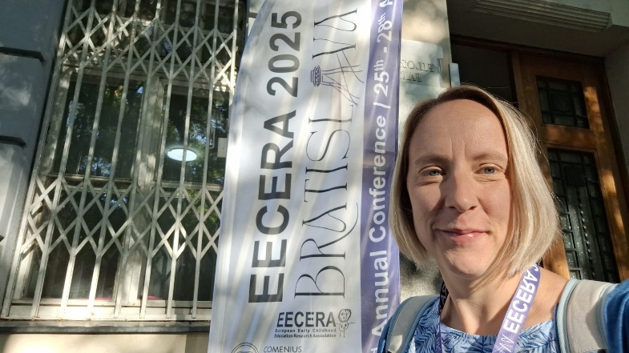
EECERA Conference, Bratislava – 25–28 August 2025
“What a brilliant few days at #Eecera2025 listening and thinking to some brilliant talks on research of listing to children and their rights. my own little person was amazing and commented that everyone was talking about him, because, he was a child”
Dr Jacky Tyrie attended EECERA 2025 presenting on children’s data and work with our children’s advisory board.
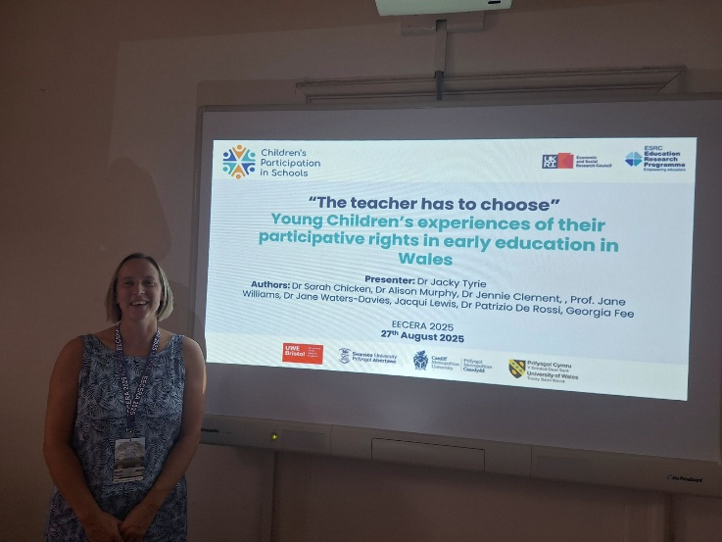

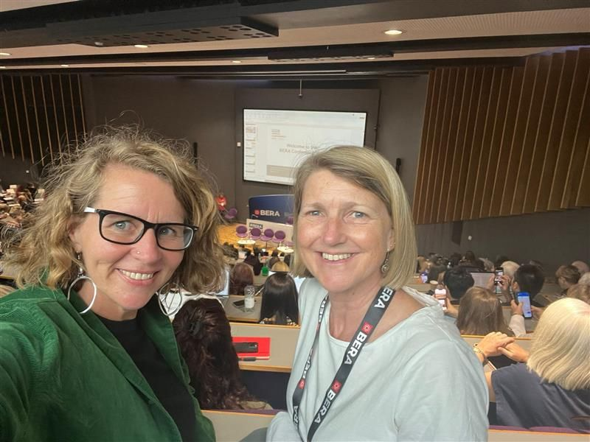
BERA Conference, Brighton– 9-11th September 2025
Dr Jane Waters-Davies and Dr Jennie Clement attended BERA presenting on findings from our work with student teachers and student teacher educators

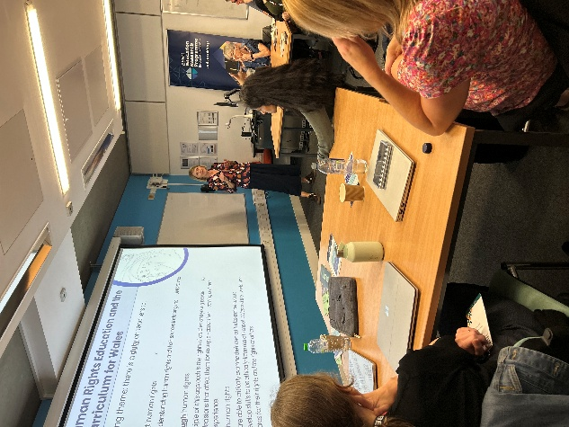
It was really interesting presenting to all of the other ERP projects, with some great conversations afterwards

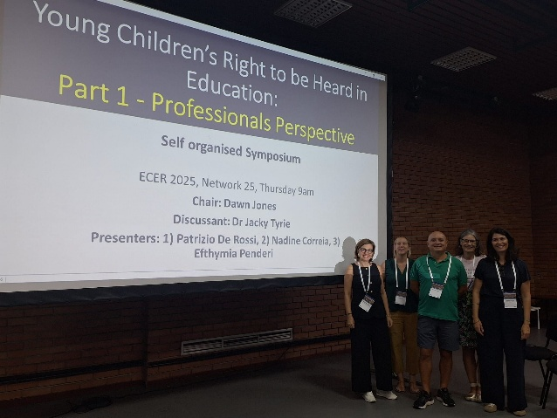
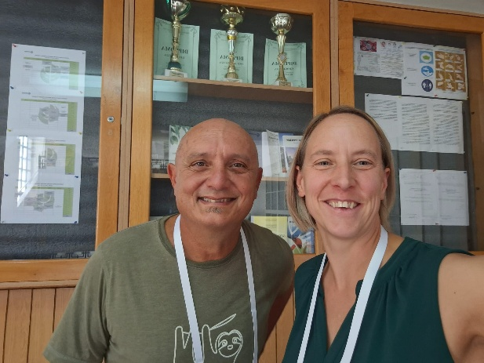
ECER Conference, Belgrade – 9-12th September 2025
It was exciting to present and get feedback for the first time on work we have been doing, developing a new model of children's participative rights, some initial outcomes of this available here.
At ECER, Dr Jacky Tyrie hosted two symposiums, with Dr Patrizio De Rossi presenting on teachers understandings of participative rights and pedagogical practices in Wales

